Private Chauffeured Tours
2 Day Personal Scenic South Island location
Christchurch > Hokitika Town ship > Franz Josef (Stay the night) > Queenstown

Be prepared for some of the most amazing scenery by road from open farm land, Mountain lakes, incredable rock formation local West Coast town and the option to land on a Glacier by helicopter.
Unlike the Tranz Alpine train we stop to take photos of these amazing sites in the Southerm Alps mountain range.
One day road trip with your personal guide
Tour map of visiting locations.
Starting in Christchurch city at 09:00.

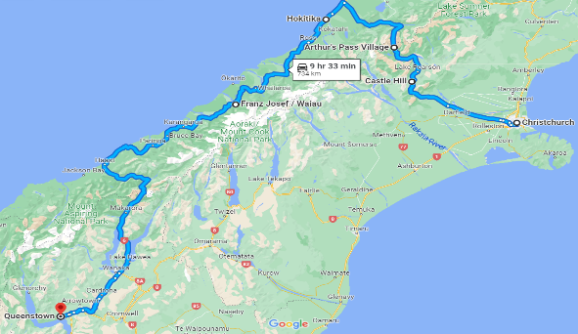
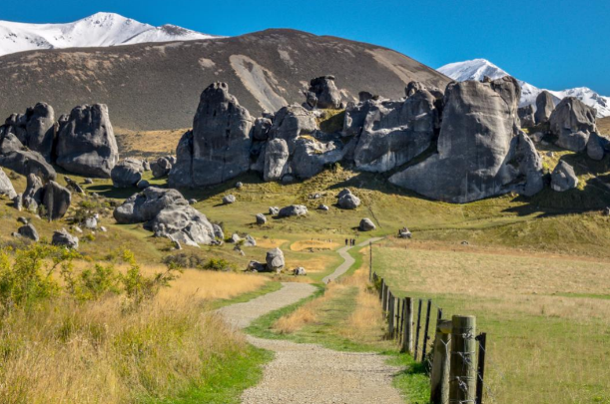
DAY ONE: Travelling from Christchurch city in your private vehicle we take you through the green farm pastures and small towns into Arthur’s pass and greet views of Castle Hill rock formation.
Let’s go for a brief walk to stetch the lets.
On this trip through the Main divide the alps that divide the East and West Coasts of New Zealand’s South Island.
First stop Christchurch to Castle Hill 1.5 hours
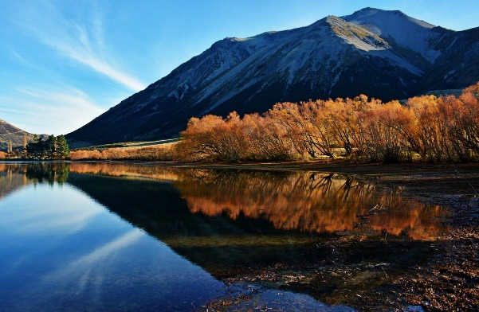
DAY ONE: Passing Lake Pearson Ōpōrea is the traditional Māori name for Lake Pearson. It is also known as Moanarua. It is a moderate sized highland lake, situated in the upper Waimakariri. This lake is a Mountain Lake at its clearest.
On our way to Arthur’s pass township and then to Hokitika township. During 1865 a flood of gold prospectors and traders arrived, and the town was occupied and booming within less than a year.
Castle hill to Lake Pearson 15 minutes
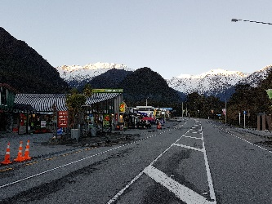
DAY ONE: Our stop for the night after a long day taking in this amazing scenery. Franz Josef is the name of both the glacier and the nearby village, though the Maori names are different.
The small but lively Franz Josef Waiau village is surrounded by lush rainforest with the high snow-capped Alps above. This is a greet opportunity to take a Franz Josef Helicopter landing flight. (Not included in our price)
Arriving late afternoon and leaving in the morning about 10am.
Lake Pearson via Arthurs Pass with lots of stops / Hokitika Township and then to Franz Josef for the night 4 hours with stops

Franz Josef Town ship accomodation suggestion. Punga Grove Motel Scenic Hotel Booking.com
When booking please make sure you are no more than 3 km from the center of Franz Josef township
DAY TWO: Let’s start our journey about 10pm down the West Coast of New Zealand is a spectacular mountain views and from a distance Franz Joseh glacier.
Travelling through the amazing green lush rain forests and clear rivers, but a bit cold. For a brief time, we reach the west coast shoreline and then back into the mountain drive to view waterfalls and then from the outskirts on Lake Wanaka past Cromwell town around the kauri george to Queenstown, our destination.
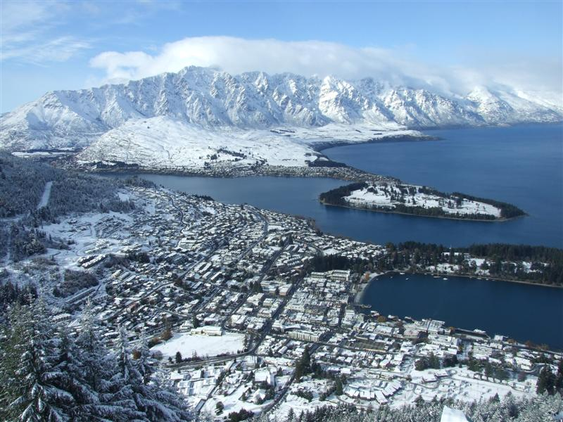
Queenstown accommodation. There is a huge choice of accommodation to stay at from B&B to 3 to 5-star hotel to resorts. Please when booking confirm you are no more than 3km from the centre of Queenstown or you may be charged an additional charge
DAY TWO: Well that’s the end for us and your opportunity to stay and explore the one of New Zealands bigest play ground for adventure.
From bungy jumping to wine trails, indoor fun at “King Pin” to snow sking in the winter and why not try the Shot over jet boat ride. I here the ice bar at night is a lot of fun and try one of the many restaurants in the area.

What we provide:
- Personal chauffeur private driver
- Personal service to meet your requirements.
- Comfortable European vehicles.
- Vehicle/fuel/ vehicle insurance/driver-guide.
- NZ government tax of 15%
- Vehicle hire and insurance cost.
What you must provide:
- Accommodation: As everyone has their own accommodations and meals requirements, we provide the town we are staying in, and you choose your own accommodation and restaurants, or we can assist you with this. Try Booking.com or Trivago for suggestions but please check with us to confirm you are staying in a proximity to our location:
- Meals:
- Personal travel insurance:
- All other personal belonging:
- Activities / meals are not included in our pricing.

Our tours are charged as per vehicle size as listed below and luggage capacity indicated. Not per passenger.

