Luxury Chauffeured Transport and Private Tours
www.chauffeurnz.com | +64 27 2511133 | info@chauffeurnz.com

Private Luxury Day Tour Christchurch > Aoraki Mount Cook > via Lake Tekapo

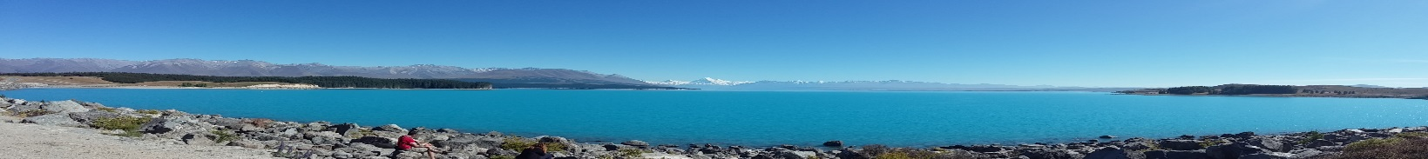

GUESTS: | AS per attached email
TOUR: | Christchurch to Aoraki Mount Cook, New Zealand. Private day Tour
Vehicle: | Executive sedan or Minivan As per email
TOUR DATE: | 2020

WHY CHAUFFEURNZ.COM
We create simplicity and ease with hiring a chauffeur service with a company dedicated to perfection in the business, we are driven in providing you with secure and comfortable transportation. When you hire us, you can rely on us exceeding your expectations with our professional, highly experienced drivers arriving on time - with your safety as their top priority, our vehicles are guaranteed to be clean, comfortable and above all safe.
One to six guests in luxury vehicles ranging from Lexus, Mercedes, Chrysler, BMW. Our chauffeur private drivers are highly experienced and

TOUR DESCRIPTION
Below is a planned outline of your days tour ending at Aoraki Mount Cook.
Your guiding chauffeur will discuss this outline with you when they meet you on arrival.
It can be tweaked to suit your requirements on the day, or scenic stops.
Many scenery stops are all included in this quotation.

YOUR EXPERIENCE TOUR OUTLINE
On this tour, you will begin by experiencing a scenic drive to the towns from Christchurch city South through the central South Island and the most incredible scenery in the world. Farms consisting of milking cows and beef cattle, and millions of white woolly sheep, part of the 29 million in New Zealand. Green open paddocks and farms for as the eye can see, and the best thing is very few people.
Our journey takes in farming townships and locale towns with small shops and cafes.

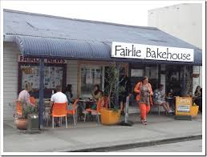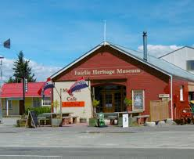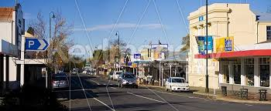
Fairlie Famous bakery Township of Geraldine

Lake Tekapo with crystal clear waters, walk down to the water’s edge, view the clear blue skies and fresh air. Snow caped Mountains that merge with the water edge.
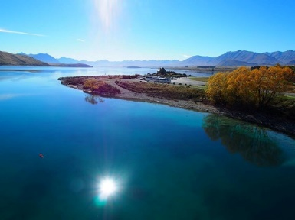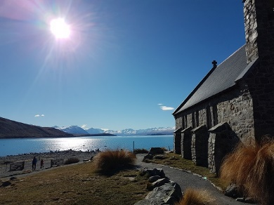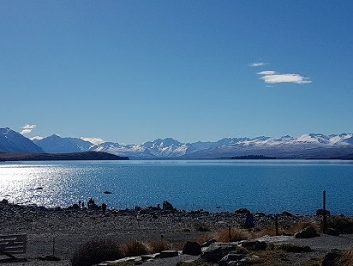

Stopping at the top of lake Pukaki with Aoraki Mount Cook in the distance. Try the local fresh salmon farm shop in the middle of nowhere. Travel to Aoraki Mount Cook maybe try a helicopter ride to the glacier and touch the fresh snow.
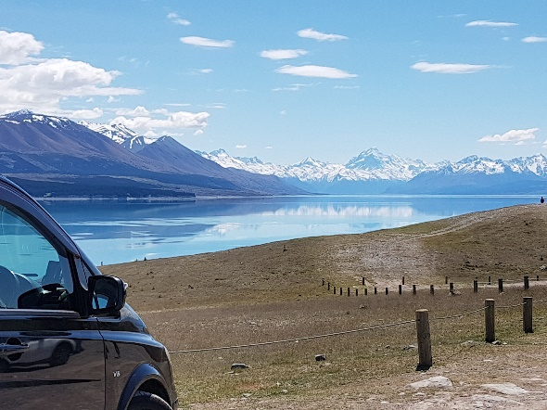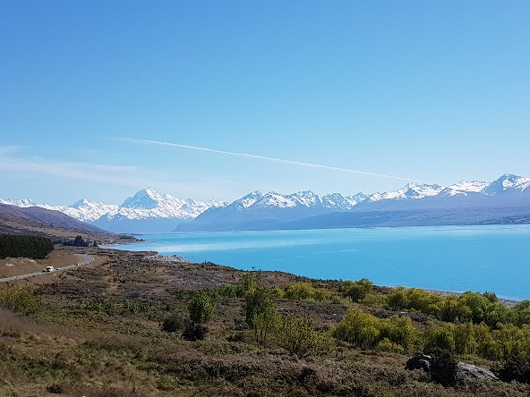
Visit the Sir Edmond Hillary centre at the Hermitage hotel. Go for a short walk but do not forget to pack your warm clothing, hats and gloves and walking shoes. This is an amazing trip to try.
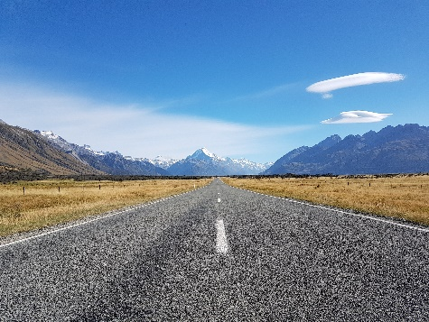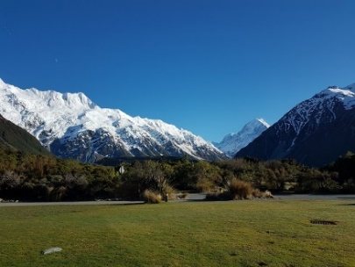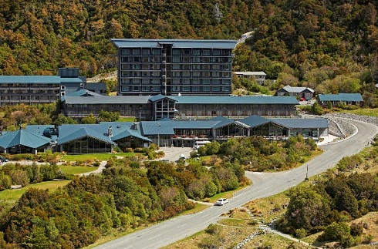
Aoraki Mount cook
PICK UP:
- 08:00 Christchurch central location.

DROP OFF MOUNT COOK:
- 14:00 Allowing 6 hours travel time. After dropping you off, the driver and vehicle return to Christchurch city.

TOWNS PASSING:
- Ashburton > Geraldine > Fairlie > Lake Tekapo final destination Aoraki Mount Cook.

LUNCH:
- We can stop in Fairlie for morning tea or lunch.

ACTIVITIES:
- Plenty of scenery stops of landscapes open green field and Mountains on the way.
- Fairlie Bakery and the famous bakery pies such as “Salmon and Bacon” fresh bread sandwiches.
- Lake Tekapo > stopping at the famous “Church of the Good Shepherd” overlooking the lake.
- Salmon Farm shop overlooking lake Pukaki and with Mount Cook in the distance.

Pricing includes:
- Your own private suited chauffeur for the tour.

Prices quoted in NZ Dollars, and include tour charges, location entrance fees and all New Zealand taxes.

TOUR PRICE: $As per email

While we have done our best to ensure all these options will be open or available, please expect to work with us as we find other fun things to do should some of them be closed or unavailable on the day due to factors beyond our control, such as weather.
www.chauffeurnz.com| +64 27 251 1133 | info@chauffeurnz.com
- Page 2 of 2 -

