Private Chauffeured Tours
1 Day Personal Scenic South Island Transfer
Picton to Christchurch 1 day transfer
Driving from Picton to Christchurch, or vice versa, is the perfect way to explore the northeast coast of the South Island! There are so many awesome stops on this drive, not to mention the drive itself is very scenic.
The best part about this road trip is you really get to experience quite the variety in a short distance. You’ll have the opportunity to see the beautiful coastline, marine life, vineyards, and even see the land from a different perspective.
The drive from Picton to Christchurch is just a little over four hours without stops. I recommend giving yourself 6 hours to complete this road trip though so you can enjoy each stop at your leisure. With stops like Black Sand Beach, wineries, and a lavender farm, I think you’re going to want to take your time!
Tour map of visiting locations.
Picton to Christchurch Road map

5 hours no stops
331 KM

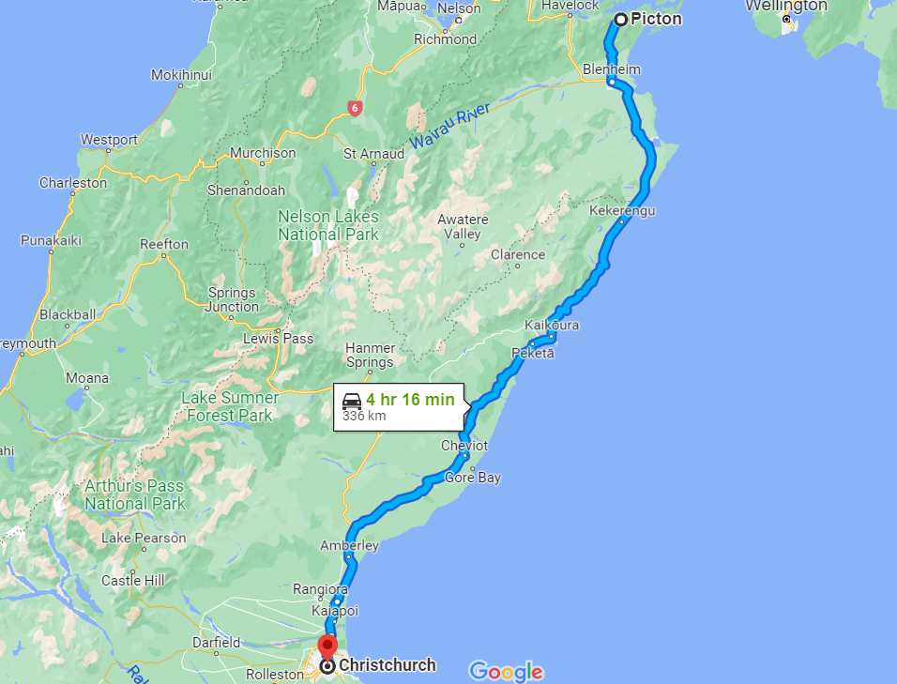
Ohau Point Viewing Platform is in prime position to watch the fur seals lazing on the rocks below. They typically don’t make too much movement; however, summer is mating season, so you’re likely to see a lot more action from Kaikoura’s most famous residents. You can see hundreds of fur seals here!
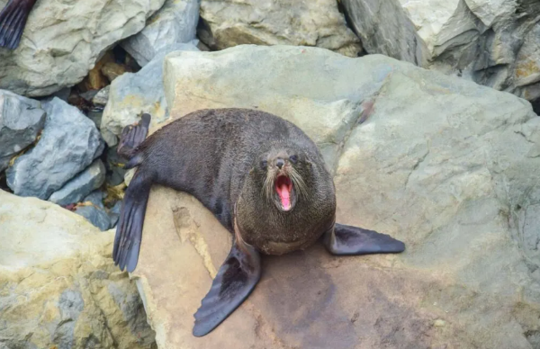
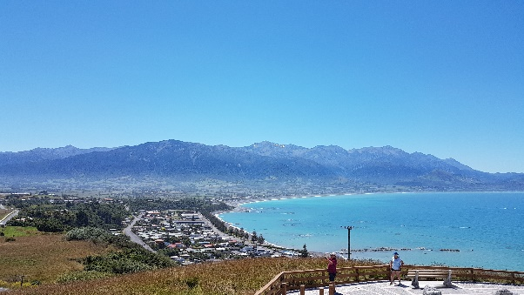
Kaikoura is probably one of the prettiest places in New Zealand. Surrounded by the Pacific Ocean and backdropped by the Kaikoura Mountain ranges – it’s one of the most popular tourist destinations on the South Island. That’s because it’s teeming with wildlife with the opportunity to see hundreds of fur seals, dolphins, blue penguins, and even whales.
Depending on the time of day lets stop to have something to eat. They make the best fish and chips.

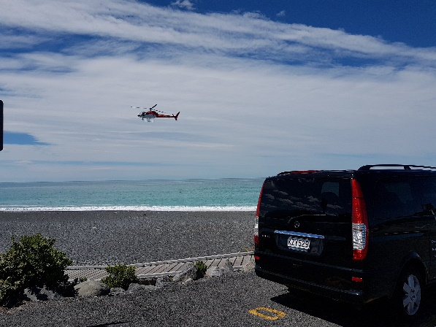
This helicopter tour departs from our beachfront heli-pads and within minutes you'll be in the spectacular environment that plays host to one of the world's largest marine mammals, the magnificent Sperm Whale. From the comfort of our helicopter, you will enjoy the ultimate whale-spotting experience.
- Enjoy spectacular, panoramic views of Kaikoura Peninsula
- See the seal colonies along the rocks at the end of Kaikoura Peninsula
- If the whales are close to shore, the possibility of spotting dolphins

Waipara Wineries. The area that has 75 wineries over 1200 hectares of plantings
Waipara is known for it's high-quality red wines based on Cabernet Sauvignon, Merlot, Malbec and Cabernet Franc grape varieties. There are around 30 boutique wineries scattered about, many with tasting rooms, swanky restaurants and breath-taking views.
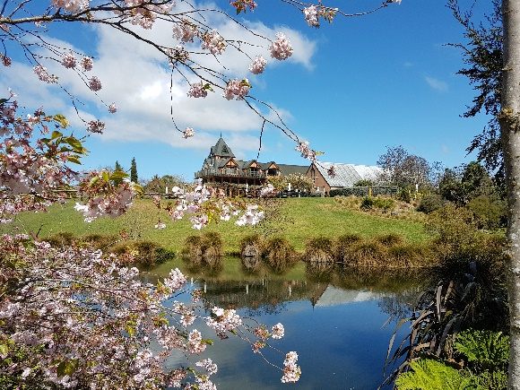

What we provide:
- Personal chauffeur private driver
- Personal service to meet your requirements.
- Comfortable European vehicles.
- Vehicle/fuel/ vehicle insurance/driver-guide.
- NZ government tax of 15%
- Vehicle hire and insurance cost.
What you must provide:
- Accommodation: Only if has been pre arranged.
- Personal travel insurance:
- All other personal belonging:
- Activities / meals are not included in our pricing.

