Welcome – Hello to all our special guests and a warm welcome from the team of ChauffeurNZ.com Christchurch New Zealand and opportunity to provide our Premier Tour from Akaroa and Christchurch. Please sit back, relax and prepare to enjoy what I am confident will be a truly enjoyable and memorable day.

Introduction – My name is Mike Halliday and I the owner of ChauffeurNZ.com New Zealand and located in Christchurch city. Upwards of 92 cruise ship visits each season (Oct to Mar). Cruise ships diverted here in October 2011, after Earthquakes of 2010 & 2011, likely to continue coming in significant numbers waiting for the new cruise ship dock and welcome areas are built in Lyttleton harbour 1.5 hour’s drive from Akaroa.

Tour time – Our tour starts when we pick you up from the wharf and we are on our way.
About your Chauffeured journey to Christchurch that takes approx. 1.5 hour plus plenty of photo opportunities. Once we finish our tours, walks, activities we leave for Akaroa about 14:30 arriving about 16:00 in time for shopping and a quick walk before boarding your ship.

Lakes Forsyth & Ellesmere (Drive by):

Lake Forsyth: Maori name Te Roto o Wairewa (rising waters) only 1 x metre deep Eels are an important part of the cultural significance of the lake to the Maori Significant because it has both fresh and salt water influences (unlike most NZ Lakes) In natures grand scheme, high tides washed in to the foot of the lake, flushing the lake and keeping open a channel for migrating fish In recent years nature has not always performed and man has needed to dredge the lake mouth Lake Ellesmere: Maori name Te Waihora (spreading waters) 5th largest lake in the South Island.

Little River (Drive through & Photos from Vehicle):

Small Rural Town serving the local farming community with essential services busy Rail Head until 1962, now very popular stopping place for travellers Bed for rail tracks preserved for Rail trail cycle way Silo stays unique alternative accommodation.

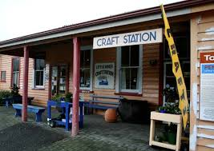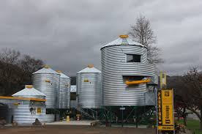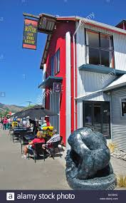

Hilltop Tavern Lookout (Drive by):

Highest point on the Akaroa Christchurch road @ 470 metres sea level Road sometimes closed by snow in Winter at this point Peninsula in foreground is Onawe, scene of a brutal massacre in 1831, where local tribe Ngai Tahu, lost a significant number of their tribe. Will talk more about Maori conflict on the Peninsula as we return from Christchurch this afternoon.
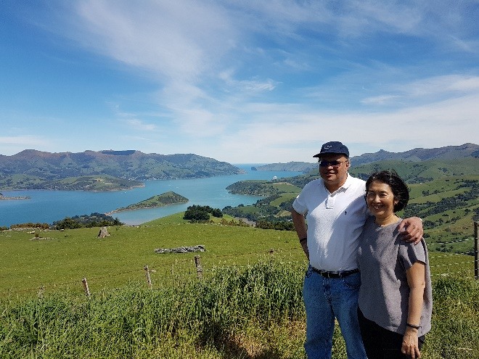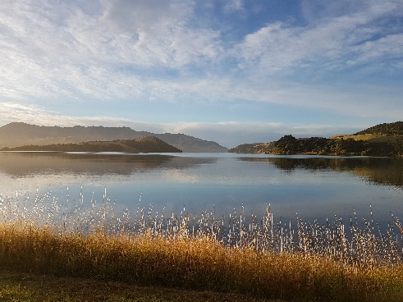
Hill top view Barry’s Bar view and the cheese factory stop
About Akaroa – Maori word (Long Harbour), 600 permanent residents, French influence, many businesses and streets have French names, numerous French Flags. French Government had decided to colonise what we now know as the South Island, and their plan was for Akaroa to be the main town and major Port of his new acquisition. A ship with 60 would be settlers aboard, set sail for Akaroa in early 1840, and arrived in August 1840, only to find that the Maori chiefs had signed a treaty with the British Crown at Waitangi near the top of the North Island, on 6th February 1840, which annexed to whole of New Zealand as a British Colony.

Fortunately, the French decided to stay on and make the most of this opportunity under British rule.

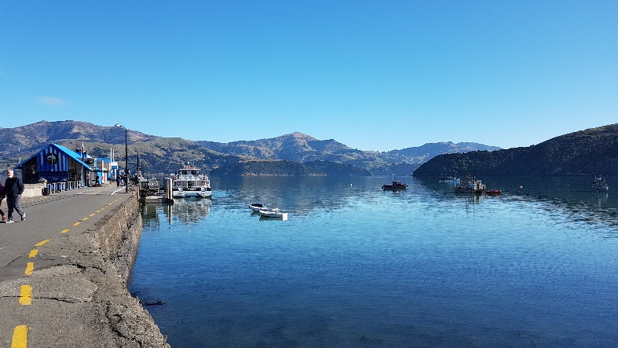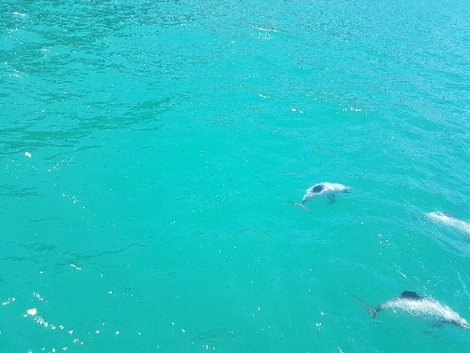
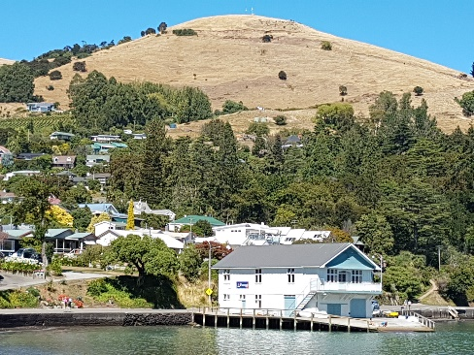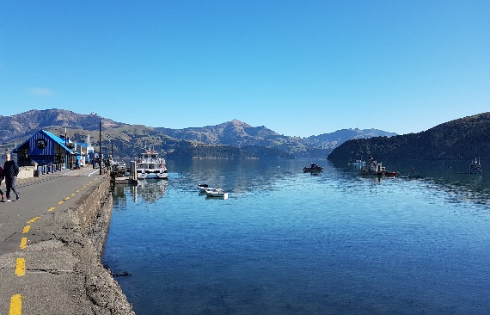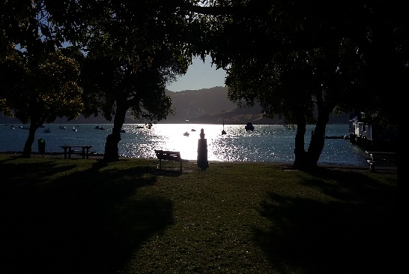
What to do while at Akaroa.

Pohatu Penguins offers unique nature walk.

Akaroa Dolphin nature cruise.

Walks around the bay

Small shops and restaurants.

ChauffeurNZ.com Christchurch New Zealand. Private Chauffeur Service. www.chauffeurnz.com info@chauffeurnz.com 0800511133 or 0064272511133 Whats app and We Chat

