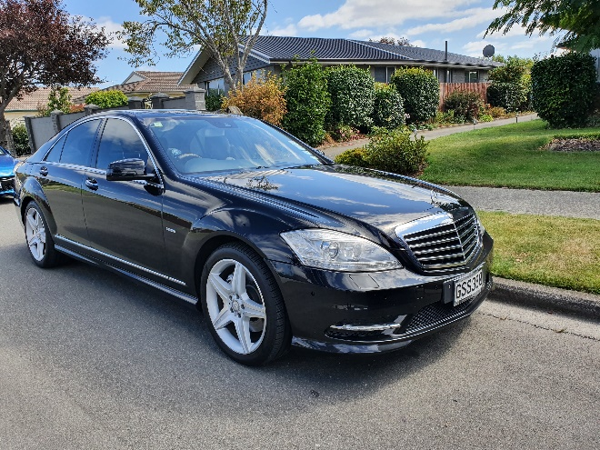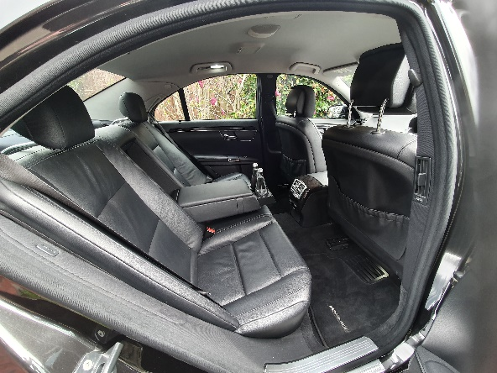
Mercedes Benz S Class 2012 Executive AMG: 2 passengers 2 large suitcases 1 carry on. Full leather luxury
Seats, water/peppermints hold.
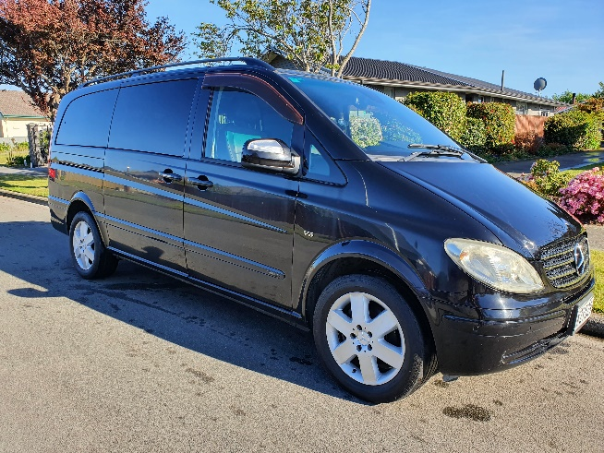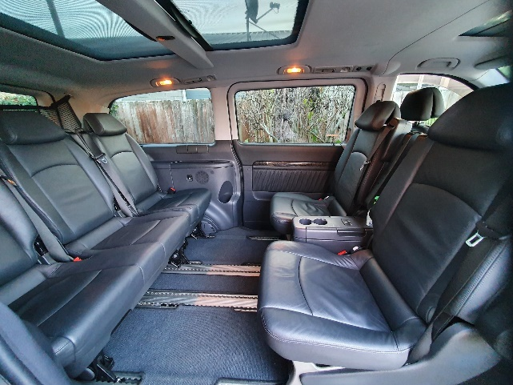
Mercedes Benz Ambiente Luxury Minivan 2011. 6 seats, 4 large bags. Full leather carpeted, sunroofs
Centre table for eating holding laptops. Device cables and charging points.
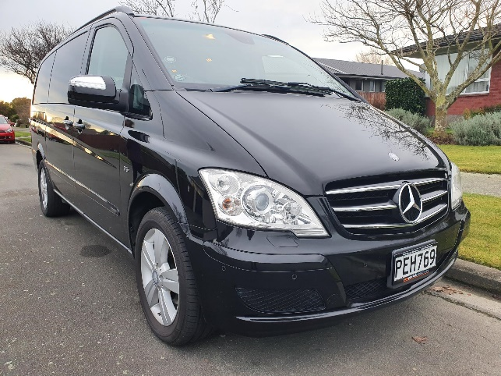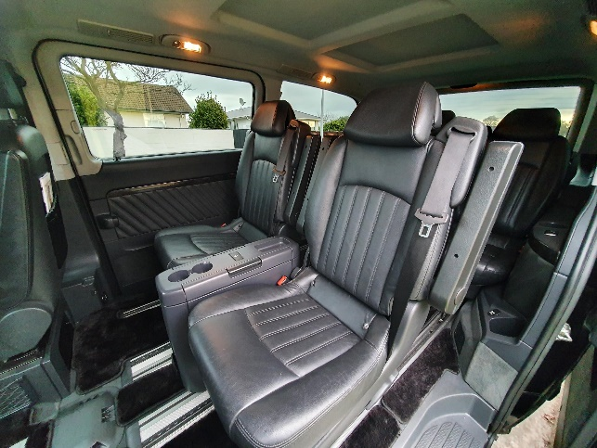
Mercedes Benz Ambiente 2012 Ambiente luxury minivan V Class: 5 seats, 4 large bags. Full leather, carpeted
Centre table for eating holding laptops. Rood DVD player/Bluetooth/. Device cables and charging points

